LAB LOGBOOK:

GITHUB:

Week-2:
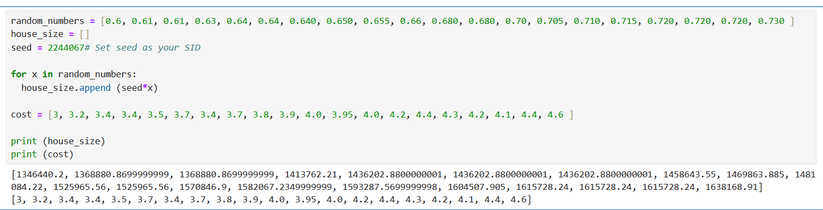
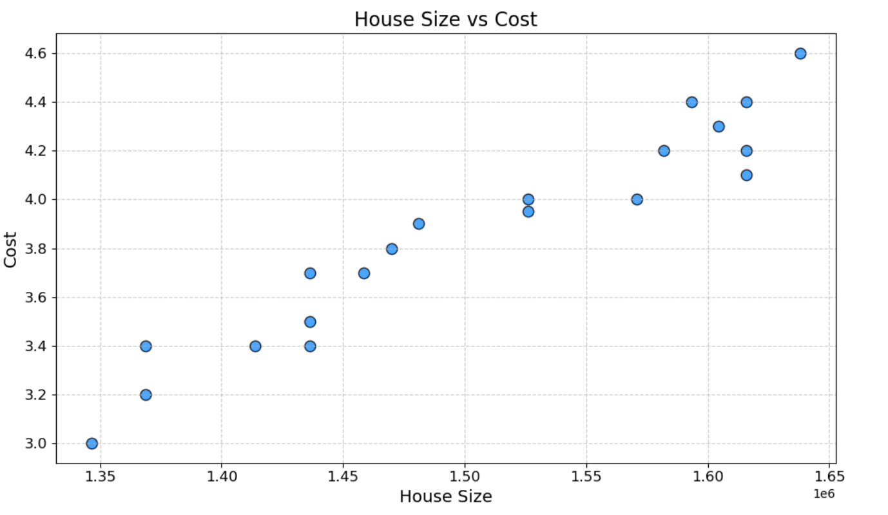
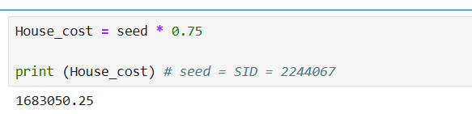

Week-3
Detecting anomalies using Z-Score:
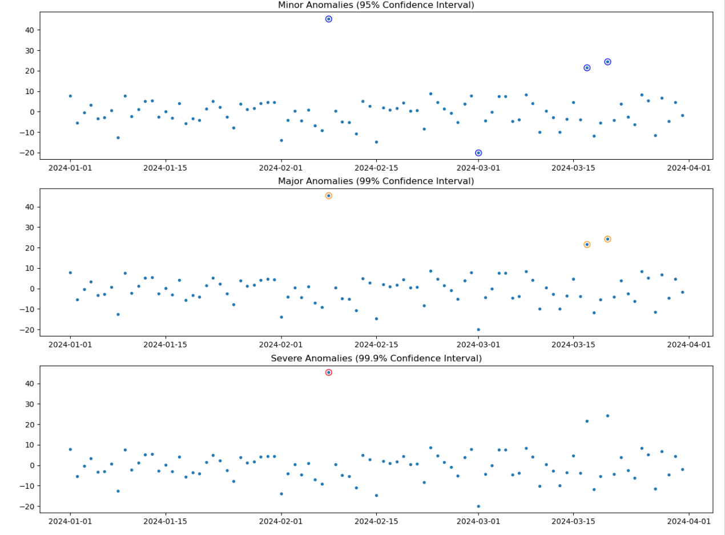
Detecting anomalies using IQR:
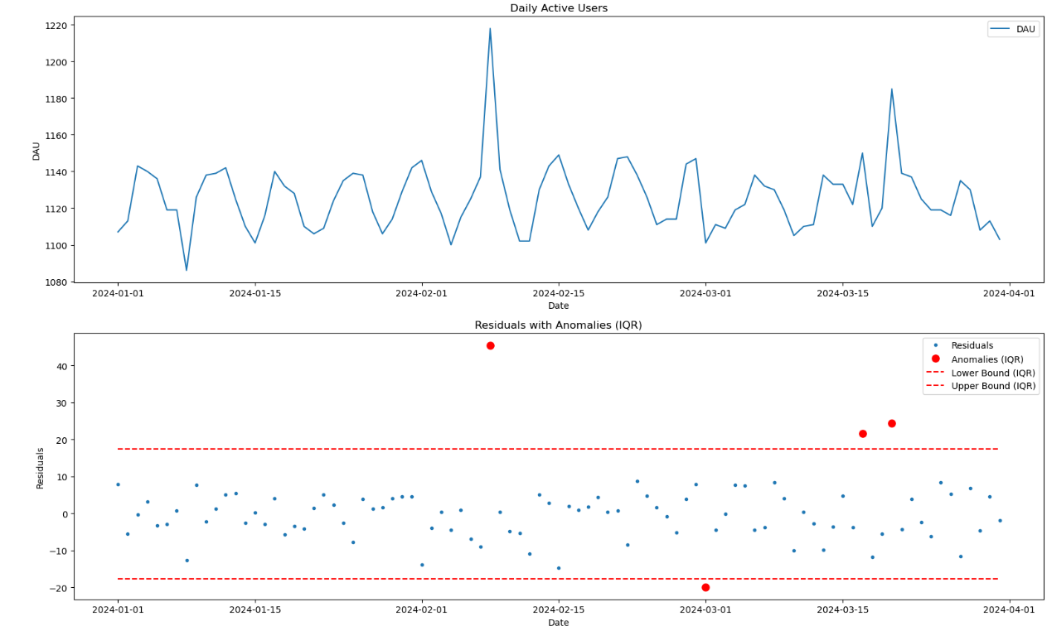

Week 4:
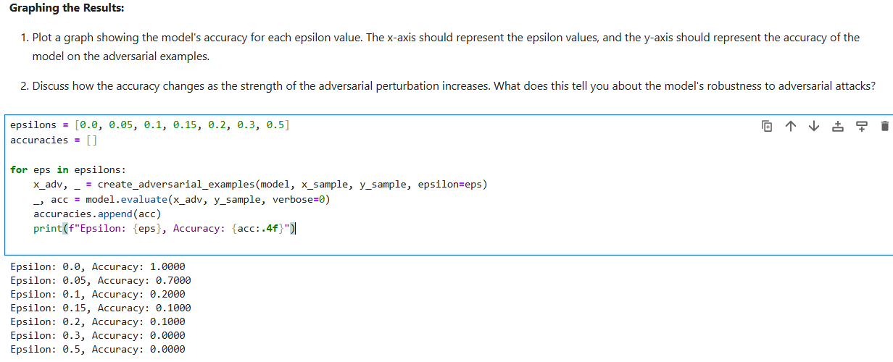
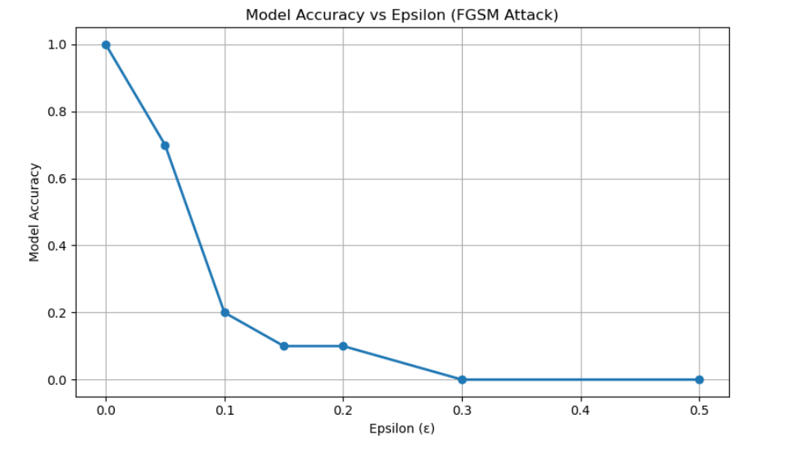
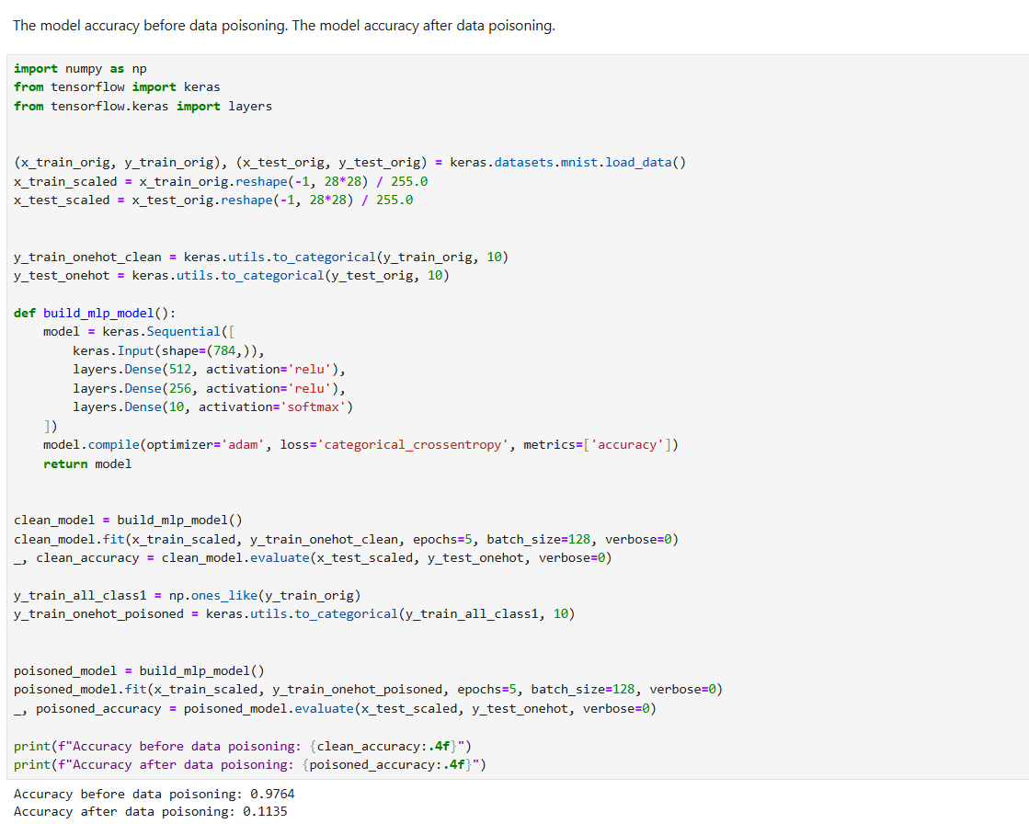

Week 5:
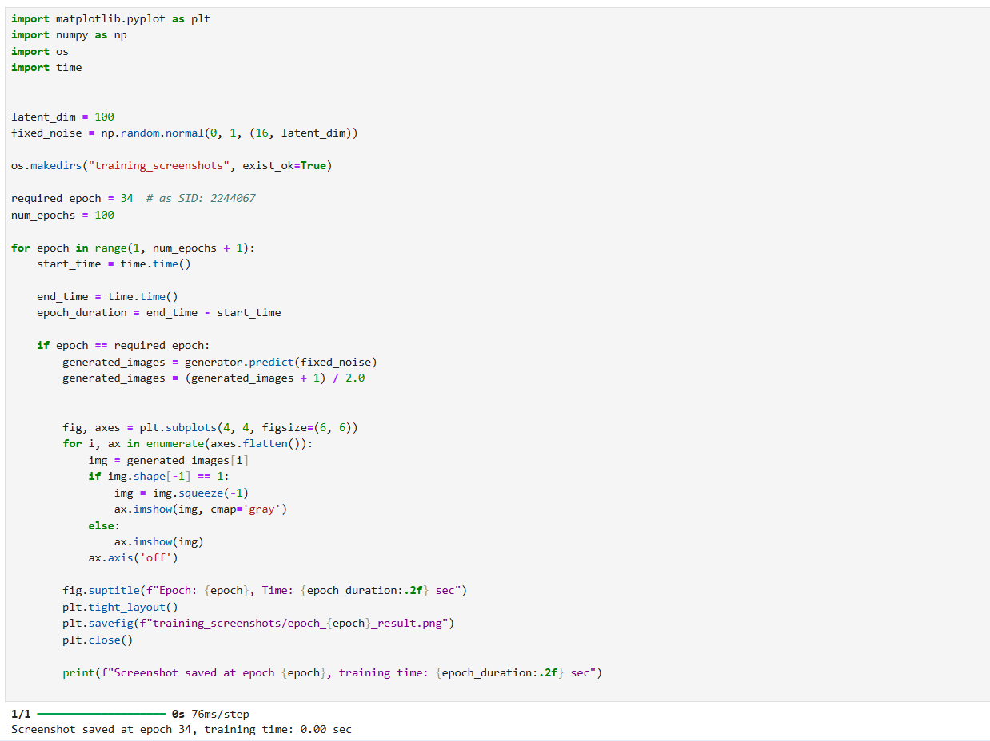
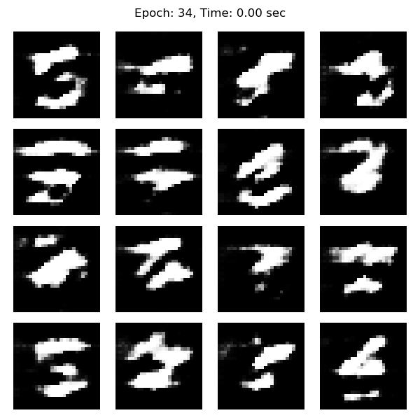

Week 6:
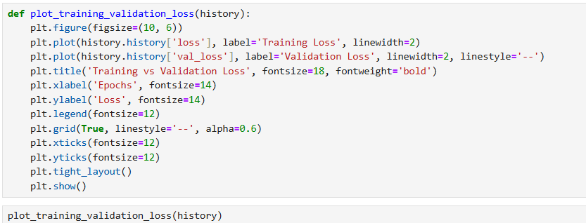
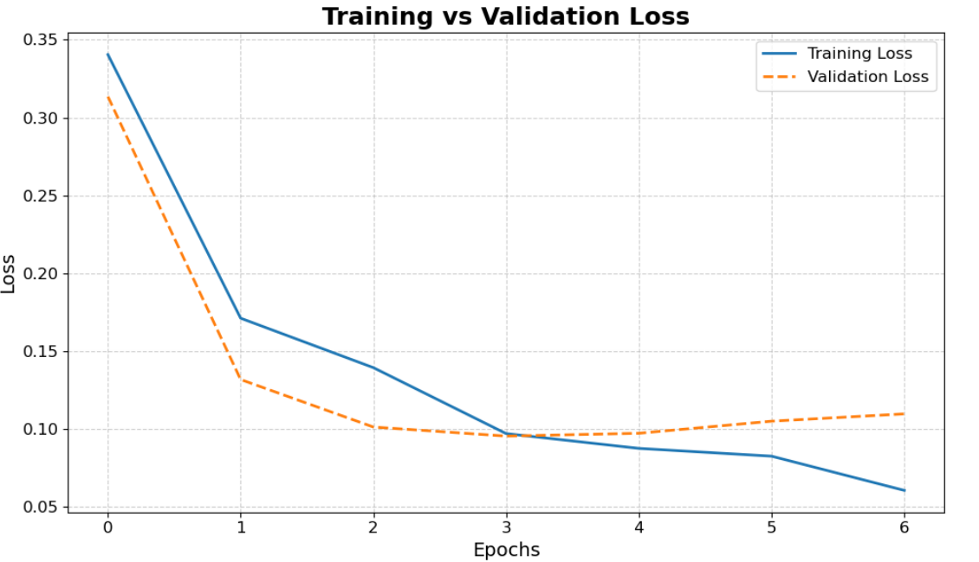

Week 7:
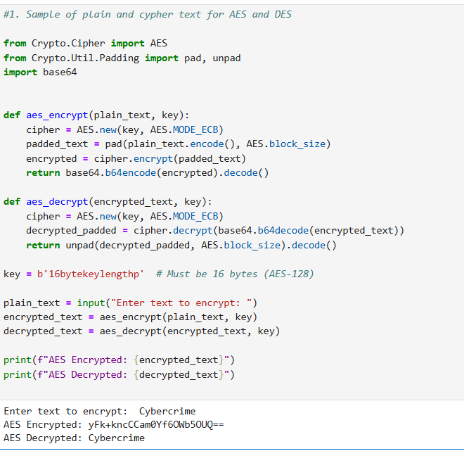
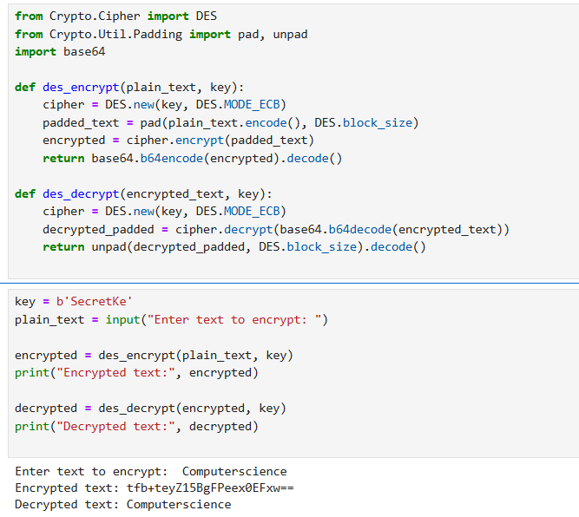
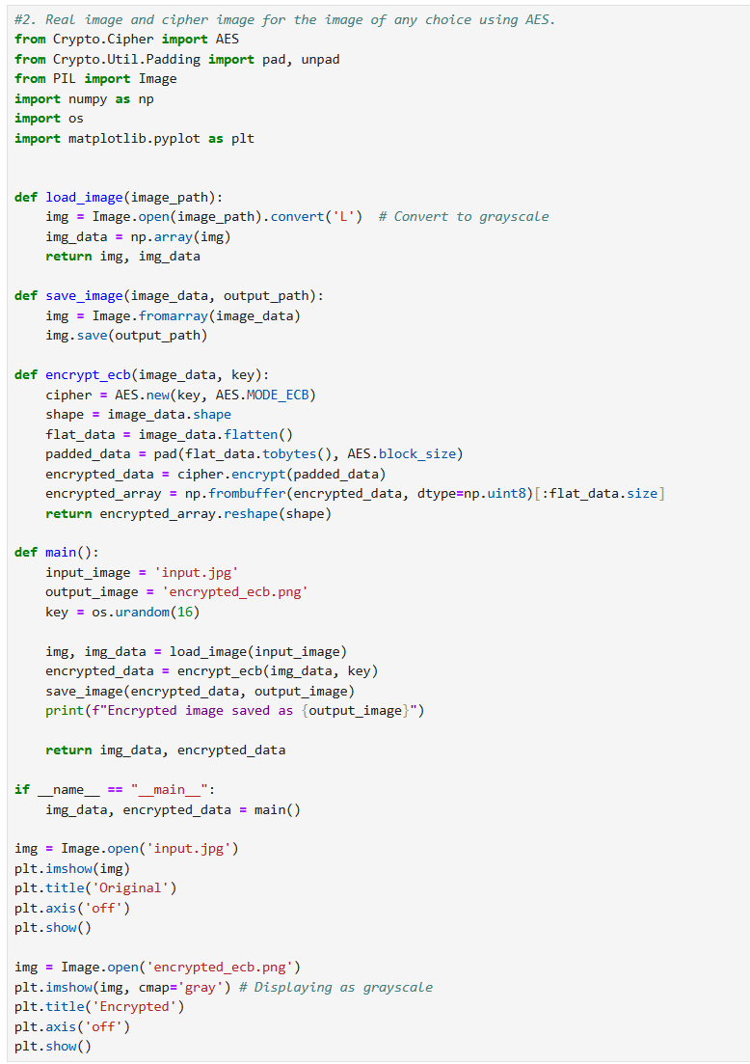
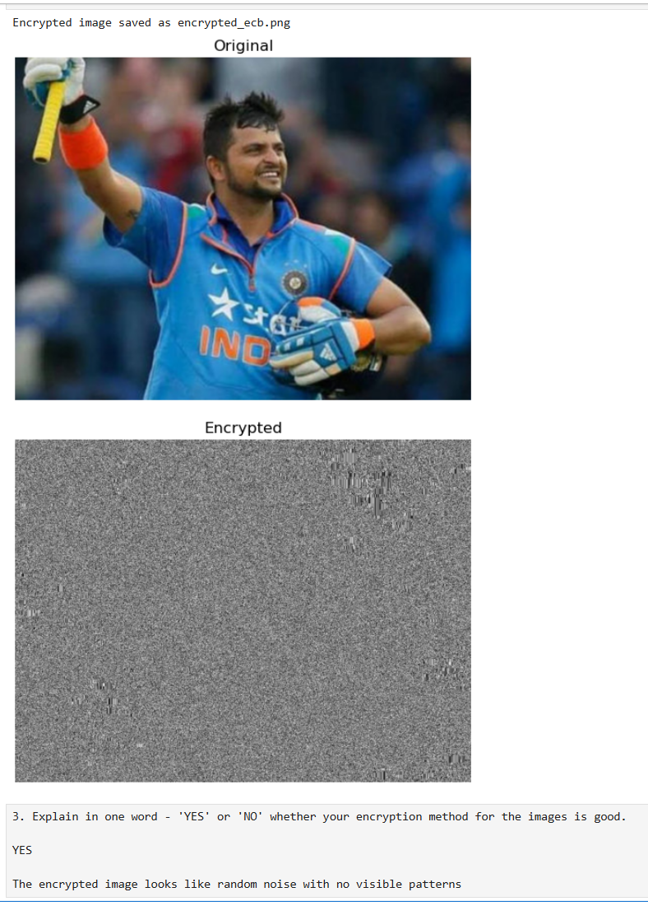

Week 8:
1. Partner’s Name:
Abdul Khadar
2. Values Used and Computed:
- Prime number (p): 7
- Base (g): 3
- My private key (a): 4
- My public key (A): 3⁴ mod 7 = 81 mod 7 = 4
- Partner’s public key (B): 5 (received from Abdul Khadar)
- Shared secret (s): 5⁴ mod 7 = 625 mod 7 = 2

Week 9:
1. Attack Type Chosen:
Microsoft Exchange Server Hack (2021) – State-sponsored hackers exploited vulnerabilities in Microsoft Exchange servers.
2. Useful Source:
https://www.cisa.gov/news-events/cybersecurity-advisories/aa21-062a
3. How it is useful:
This official alert from the U.S. Cybersecurity and Infrastructure Security Agency (CISA) explains the vulnerabilities, indicators of compromise (IOCs), and mitigation steps recommended for affected organizations.

Week 10:
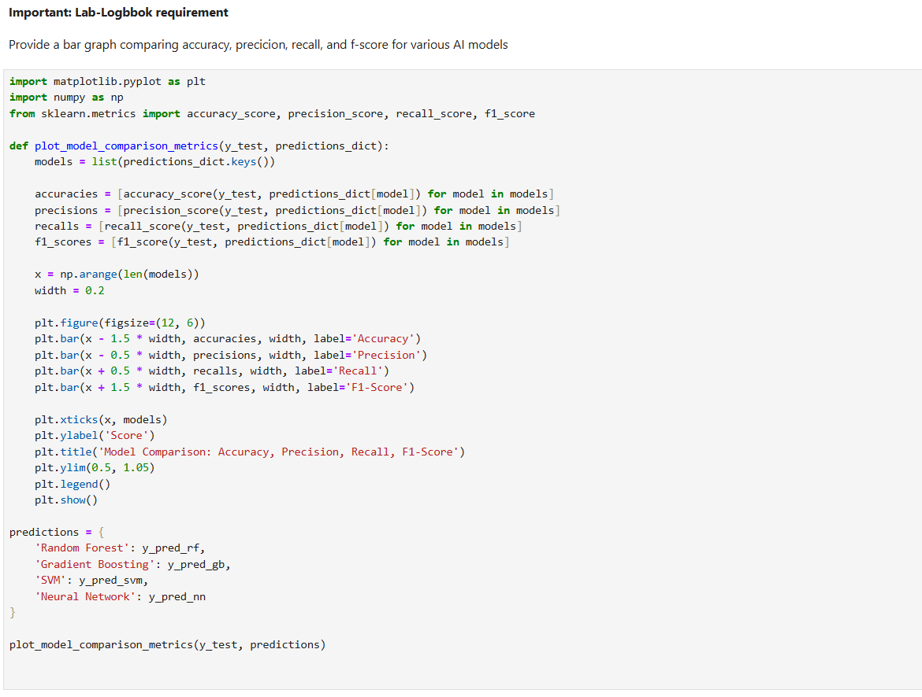
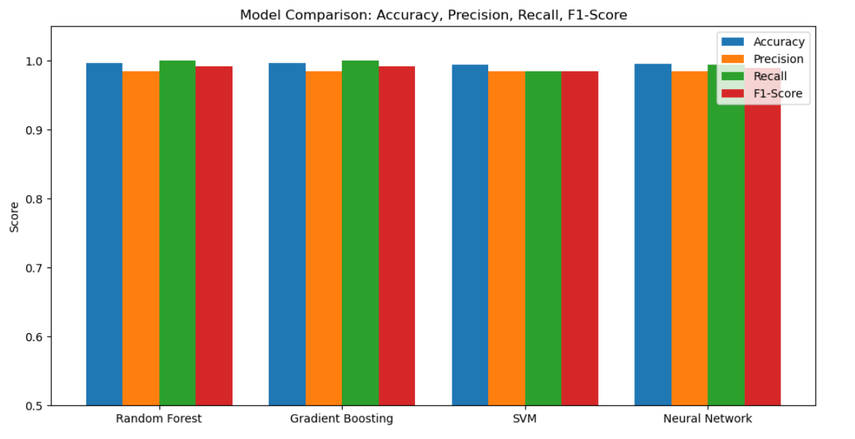

Week 11:
